**Radiographic Positioning Training template**

**Define the following terms:**

* **Isocentric**

……………………………………………………………………………………………………………………………………………………………………………………………………………………………………………………………………………………………………………………………………………………………………………………………………………………………………………………………………………………..

* **Prone**

…………………………………………………………………………………………………………………………………………………………………………………………………………………………………………

* **Supine**

…………………………………………………………………………………………………………………………………………………………………………………………………………………………………………

* **Lateral**

…………………………………………………………………………………………………………………………………………………………………………………………………………………………………………

* **Distal**

…………………………………………………………………………………………………………………………………………………………………………………………………………………………………………

* **Proximal**

…………………………………………………………………………………………………………………………………………………………………………………………………………………………………………

* **Medial**

…………………………………………………………………………………………………………………………………………………………………………………………………………………………………………

* **Axial (transverse)**

…………………………………………………………………………………………………………………………………………………………………………………………………………………………………………

* **Sagittal**

…………………………………………………………………………………………………………………………………………………………………………………………………………………………………………

* **Coronal**

…………………………………………………………………………………………………………………………………………………………………………………………………………………………………………

**Draw on the diagram below to identify:**

* **Centering points for head & neck imaging**
* 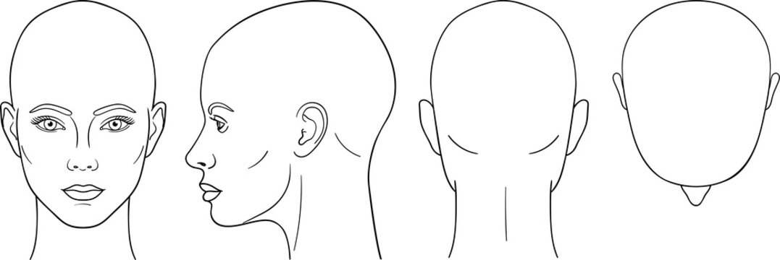**The baselines/reference lines used for positioning.**

**How does the chin position differ for different head imaging protocols?**

……………………………………………………………………………………………………………………………………………………………………………………………………………………………………………………………………………………………………………………………………………………………………………….

**How else do you prepare a patient for head and neck imaging?**

…………………………………………………………………………………………………………………………………………………………………………………………………………………………………………

**Draw on the diagram below to identify:**

**• Centering points for body imaging**

**• The baselines/reference points used for positioning**

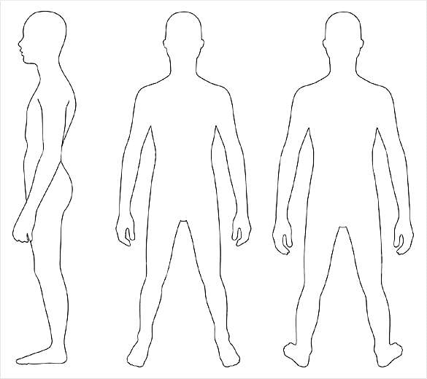

**Which scans might we position prone?**

…………………………………………………………………………………………………………………………………………………………………………………………………………………………………………………………………………………………………………………………………………………………………………………………………………………………………………………………………………………………………………

**How else do you prepare a patient for body imaging?**

…………………………………………………………………………………………………………………………………………………………………………………………………………………………………………

**What is the importance of using the plastic arm rest?**

…………………………………………………………………………………………………………………………………………………………………………………………………………………………………………………………………………………………………………………………………………………………………………………………………………………………………………………………………………………………………………

**Any other notes:**

……………………………………………………………………………………………………………………………………………………………………………………………………………………………………………………………………………………………………………………………………………………………………………….……………………………………………………………………………………………………………………………………………………………………………………………………………………………………………………………………………………………………………………………………………………………………………….……………………………………………………………………………………………………………………………………………………………………………………………………………………………………………………………………………………………………………………………………………………………………………….……………………………………………………………………………………………………………………………………………………………………………………………………………………………………………………………………………………………………………………………………………………………………………….…………………………………………………………………………………………………………………………

In the event of any queries please contact the Practice Educator.