Radiographic Positioning Training template
Define the following terms:
- Isocentric
……………………………………………………………………………………………………………………………………………………………………………………………………………………………………………………………………………………………………………………………………………………………………………………………………………………………………………………………………………………..
- Prone
…………………………………………………………………………………………………………………………………………………………………………………………………………………………………………
- Supine
…………………………………………………………………………………………………………………………………………………………………………………………………………………………………………
- Lateral
…………………………………………………………………………………………………………………………………………………………………………………………………………………………………………
- Distal
…………………………………………………………………………………………………………………………………………………………………………………………………………………………………………
- Proximal
…………………………………………………………………………………………………………………………………………………………………………………………………………………………………………
- Medial
…………………………………………………………………………………………………………………………………………………………………………………………………………………………………………
- Axial (transverse)
…………………………………………………………………………………………………………………………………………………………………………………………………………………………………………
- Sagittal
…………………………………………………………………………………………………………………………………………………………………………………………………………………………………………
- Coronal
…………………………………………………………………………………………………………………………………………………………………………………………………………………………………………
Draw on the diagram below to identify:
- Centering points for head & neck imaging
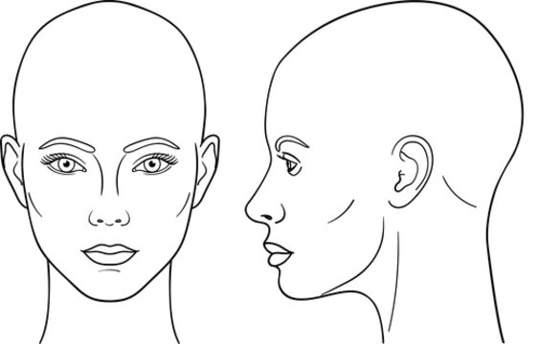
- The baselines/reference lines used for positioning.

How does the chin position differ for different head imaging protocols?
……………………………………………………………………………………………………………………………………………………………………………………………………………………………………………………………………………………………………………………………………………………………………………….
How else do you prepare a patient for head and neck imaging?
…………………………………………………………………………………………………………………………………………………………………………………………………………………………………………

Draw on the diagram below to identify:
• Centering points for body imaging
• The baselines/reference points used for positioning
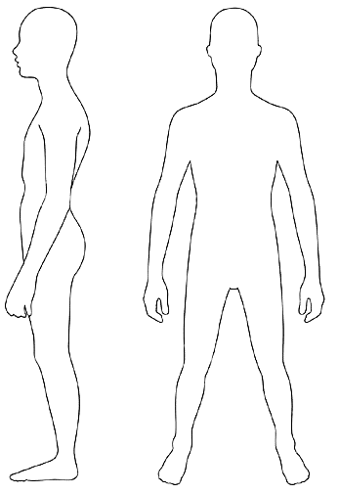

Which scans might we position prone?
…………………………………………………………………………………………………………………………………………………………………………………………………………………………………………………………………………………………………………………………………………………………………………………………………………………………………………………………………………………………………………
How else do you prepare a patient for body imaging?
…………………………………………………………………………………………………………………………………………………………………………………………………………………………………………

What is the importance of using the plastic arm rest?
…………………………………………………………………………………………………………………………………………………………………………………………………………………………………………………………………………………………………………………………………………………………………………………………………………………………………………………………………………………………………………

Any other notes:
……………………………………………………………………………………………………………………………………………………………………………………………………………………………………………………………………………………………………………………………………………………………………………….……………………………………………………………………………………………………………………………………………………………………………………………………………………………………………………………………………………………………………………………………………………………………………….……………………………………………………………………………………………………………………………………………………………………………………………………………………………………………………………………………………………………………………………………………………………………………….……………………………………………………………………………………………………………………………………………………………………………………………………………………………………………………………………………………………………………………………………………………………………………….…………………………………………………………………………………………………………………………
In the event of any queries please contact the Practice Educator.

