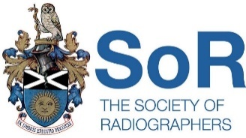


Midlands Region Committee Exec Meeting 4TH December 2023

The Barn at Hockley Heath B94 6NX at 9:30am (Exec meeting)

1030- 4pm MRC Members (on-line attendance option available)

Chair: Amy Ensell Harper Vice Chair: Jamie Sylvester
Secretary: Shama Niazi. Please seen apologies to Secretary: s.niazi@nhs.net
Agenda:
AGM 2pm: Voting MRC Committee/ Executive Committee Officers Positions/ MRC Constitution.
MRC Meeting 1030:
- Apologies
- Minutes from pervious MRC meeting
- Matters arising
- Correspondence
- MRC Constitution
- MRC study Day 2024
- Chesney award
- Rep of Year/ Radiographer/ Team of year nominations
- ADC 2024
- Update from Council
- Update from FTO
- Officers report.
- AOB
Afternoon session: AGM / ADC Motions.

