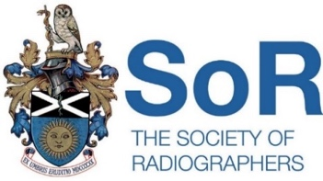
SOCIETY OF RADIOGRAPHERS LIFE AND LIMB COVER PRO-FORMA

Strike Date: 8am Tuesday 25th July 2023 to 8am Thursday 27th July 2023
Trust: ………. Insert name
To: ………. Insert manager’s name
From: ………Insert your name … Society of Radiographers Accredited Industrial Relations Representative.
Re: Provision of Life and Limb cover (derogations) during strike action called by the Society of Radiographers.
The following examinations/treatments will be provided for the duration of the strike in each modality within the Trust.
Modality | Service Provision | Required number of staff and Band | Date of shift | Time of shift | Number of staff and band working
 | (eg bank holiday level of cover; CT head; trauma)
Example - CT | Christmas day | 1 Band 7 1 band 6 2 band 5 | 25th July 2023 | 8am to 5pm | 1 Band 7 1 band 6  2 band 5

Signed………………………………………. Date……………………………….
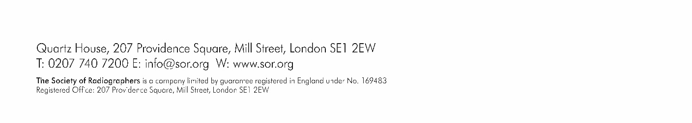
SoR Industrial Relations Representative

