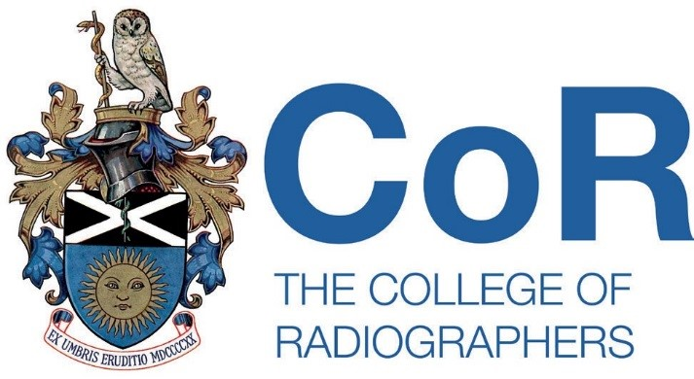

Legacy Fund
Established in 2016

Introduction
The College of Radiographers (CoR) Legacy Fund has been established following receipt of a generous donation and will be used to support two areas of work.

Part 1: Overseas Conference Grant
A grant will be made annually and will support a qualified member of the Society of Radiographers, United Kingdom, or a small team of members, to travel overseas to present the findings of their research and/or service evaluation as an oral paper at an international conference.

Successful applicants also agree to prepare an article for publication in Synergy: Imaging and Therapy Practice on their experience; and to publish the findings of their work in Radiography.

Applications for funding to the value of £1000 will be considered although, for exceptional applications, more may be available.

There will be two grant calls per year – one in April and one in October – with one successful grant allocation in each round. Closing dates for 2017 are Friday 28th April and Monday 2nd October, respectively.

Criteria for applications
Radiographers wishing to be considered for this grant must:

- Be a member of the Society of Radiographers (SoR)
- Hold current registration with the Health and Care Professions Council (HCPC)
- Be prepared to act as an ambassador for the Society and College of Radiographers during the conference visit and at all times in relation to the receipt and use of the grant.
- Successful individuals will be required to sign and adhere to the terms of reference for representing the Society and College of Radiographers.

Applications
Those wishing to apply for the grant are required to submit a 1500 word proposal outlining their work. This should include:

- How the paper is expected to impact on patient care
- Expected outcomes from their work

The application must be accompanied by detailed anticipated costs, to include travel, accommodation, subsistence, and other anticipated expenditure.

Part 2: Eponymous Lecture
The Legacy Fund will also support an invited speaker to deliver one of the College of Radiographers eponymous lectures.

A recommendation will be made by the College Board of Trustees (CBoT) in relation to an overseas speaker.

The grant for this invited speaker will cover travel and accommodation costs at the discretion of CBoT.

