To:
Insert name of Rep

Inset Date …………

Dear Picket Supervisor,

This letter is written confirmation that the Society of Radiographers (SoR) has appointed you as a picket supervisor for the SoR to supervise picketing for the current programme of strike action in the Society of Radiographer pay dispute. SoR Industrial Relations reps are the default picket supervisors for their Trust’s pickets.

The SoR has approved pickets at NHS workplaces identified in its strike action notification letter to your employer Insert Date………., giving notice of strike action from Insert date and times……….

As a picket supervisor, you are required to:

- Supervise the picketing;
- Be present while the picketing is taking place or be readily contactable by the union and the police and able to attend at short notice;
- Wear something which will identify you as the picket supervisor. The SoR will be sending a “Picket Supervisor” armband to every picket supervisor.

If any person acting on behalf of the Trust asks to see this approval letter, then you must show this letter to them as soon as is reasonably practicable.

I would like to remind you that the definition of picketing is attendance at or near a place of work, in contemplation or furtherance of a trade dispute for the purpose of either:

- Obtaining or communicating information; or
- Persuading any person to work or abstain from working.

Thank you for supporting our members by being a picket supervisor. Yours sincerely,
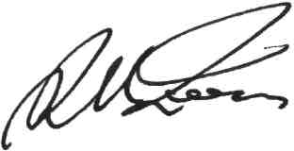
Richard Evans OBE, Chief Executive Officer

